Lab 3 Full Adder

Answer Sheet

Name: ______Wong Wai Chun____ Student ID: ___1155173231_______(CE)

1. Determine the truth tables for the 1-bit full adder. [16 marks]

|  |  |  |  |  |
| --- | --- | --- | --- | --- |
| Ci | A | B | Co | S |
| 0 | 0 | 0 | 0 | 0 |
| 0 | 0 | 1 | 0 | 1 |
| 0 | 1 | 0 | 0 | 1 |
| 0 | 1 | 1 | 1 | 0 |
| 1 | 0 | 0 | 0 | 1 |
| 1 | 0 | 1 | 1 | 0 |
| 1 | 1 | 0 | 1 | 0 |
| 1 | 1 | 1 | 1 | 1 |

1. Write down the simplified logic functions of S and Co in terms of A, B, and Ci, using XOR, AND, and OR gates. [18 marks]

S = _________________A_XOR_B_XOR_Ci__________________________

Co =

AB+BCi+ACi+ABCi

=AB(1+Ci)+BCi+ACi

=AB+Ci(A+B)

=AB+Ci((A+B)(AB)’+(AB))

=AB+Ci(A XOR B)+C(AB)

=AB(1+C)+ Ci(A XOR B)

= AB+ Ci(A XOR B)

1. Build the 1-bit full adder in Logisim and submit the .circ file. [20 marks]
2. Design a 2-bit full adder by using two 1-bit adders. Sketch the circuit below by connecting the 1-bit Full Adder building blocks. Please noted that A1A0 and B1B0 are two 2-bit binary numbers with A0 and B0 are the LSBs. [10 marks]

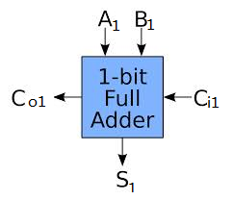 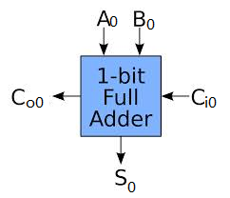

1. Fill in the decimal number represented by the outputs below. [16 marks]

|  |  |  |  |  |
| --- | --- | --- | --- | --- |
| B1 | B0 | A1 | A0 | **Output in DEC** |
| 0 | 0 | 0 | 0 | 0 |
| 0 | 0 | 0 | 1 | 1 |
| 0 | 0 | 1 | 0 | 2 |
| 0 | 0 | 1 | 1 | 3 |
| 0 | 1 | 0 | 0 | 1 |
| 0 | 1 | 0 | 1 | 2 |
| 0 | 1 | 1 | 0 | 3 |
| 0 | 1 | 1 | 1 | 4 |
| 1 | 0 | 0 | 0 | 2 |
| 1 | 0 | 0 | 1 | 3 |
| 1 | 0 | 1 | 0 | 4 |
| 1 | 0 | 1 | 1 | 5 |
| 1 | 1 | 0 | 0 | 3 |
| 1 | 1 | 0 | 1 | 4 |
| 1 | 1 | 1 | 0 | 5 |
| 1 | 1 | 1 | 1 | 6 |

1. Build the 2-bit adder using Logisim and submit the .circ file. [20 marks]